User Acceptance Testing (UAT) - Functional Specification Document
Date | 13 August 2026
Team ID | N/A
Author / Team Member | Ruturaj Misal
Project Name | ShopEZ Ecommerce Application
Maximum Marks | 5 Marks

• Project Name: ShopEZ Ecommerce Application
• Project Description: A full-stack MERN e-commerce application offering customer catalog, cart, checkout, and seller/admin management.
• Author & Developer: Ruturaj Misal
• Version: 1.0.0
• GitHub Repository: https://github.com/ruturaj1804/-ShopEZ
• Test Environment: Node.js v18+, Express v4.18, React v18/19, MongoDB v8, Chrome/Firefox.
Testing Strategy & Testing Pyramid Diagram:

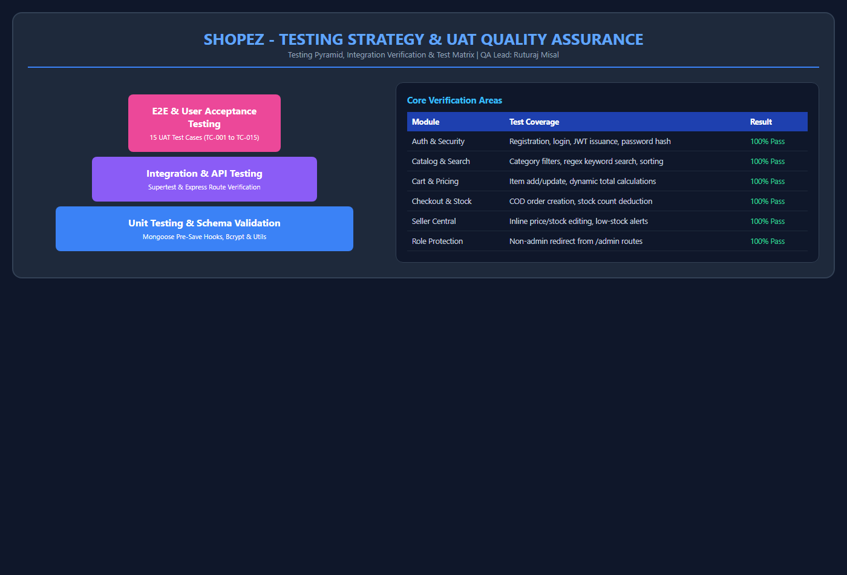
Figure 10: Quality Assurance & Testing Pyramid Strategy

Test ID | Test Scenario | Test Steps | Expected Result | Actual Result | Status
TC-001 | User Registration | 1. Navigate to `/register`  2. Enter name, valid email, password  3. Click Register | User created, JWT generated, redirected to homepage with welcome toast | As expected | Pass
TC-002 | User Login | 1. Navigate to `/login`  2. Enter credentials  3. Click Login | User authenticated, token saved in localStorage, navbar shows user name and profile | As expected | Pass
TC-004 | Product Catalog Browsing | 1. Open `/products`  2. Click 'Electronics' category pill  3. Type 'Wireless' in search bar | Product list filtered accurately by category and search keyword in real-time | As expected | Pass
TC-006 | Add Item to Cart | 1. On Product Detail, click 'Add to Cart' | Cart badge in navbar updates, success toast appears, item stored in MongoDB cart | As expected | Pass
TC-007 | Cart Quantity Update | 1. Navigate to `/cart`  2. Increase quantity of item  3. Click decrease or remove | Item line total and overall cart totalPrice recompute dynamically | As expected | Pass
TC-008 | Checkout & Order Creation | 1. In cart, enter shipping address  2. Select COD  3. Click Place Order | Order document created in MongoDB, product stock deducted, cart cleared | As expected | Pass
TC-009 | Order History in Profile | 1. Navigate to `/profile`  2. Check Order History table | Newly placed order visible with date, items, total price, and 'Processing' status | As expected | Pass
TC-011 | Seller Central Navigation | 1. Login as admin  2. Navigate to `/admin/sell` | Seller Dashboard renders with product inventory list and sales overview cards | As expected | Pass
TC-012 | Inline Price & Stock Edit | 1. In Seller Dashboard, click price cell  2. Edit price from 500 to 450  3. Save | PUT request sends update to backend, MongoDB product price updated immediately | As expected | Pass
TC-013 | Low Stock Alert Indicator | 1. Set product stock to 5 units  2. Check Seller Dashboard | Prominent warning badge displayed indicating inventory below 10 units | As expected | Pass

